Sunrise River Beach Resort is a two-star hotel complex, which is located approximately 1.5 km from the center of the town of Aheloy and 300 m from the beach, close to the Aheloy campsite. The Aheloy River flows past it, flowing into the Black Sea, 400 m away from the Sunrise River Beach Resort. The hotel complex is located 22 km from the city of Burgas, 17 km from Airport Burgas, 8 km from Sunny Beach and 10 km from the ancient city of Nessebar.

In an area of 55 000 m², along beautiful alleys and plants, there are two 6-storey buildings with reception, four buffet restaurants with a covered terrace, a snack bar, a lobby bar, a mini market, a grocery store, a mini club (3-6 years) with yard, adjacent playground and a sandpit, an amphitheater with 600 seats, two outside pools with integrated kids sections, a pool bar, a river quay, free parking. Bicycle, scooter and car rental, currency exchange, doctor are available for guests' convenience.

Special attention is paid to the sports opportunities and the organization of children’s training camps. The following facilities are located on the land of the complex:
- Multifunctional hall of 28.3/16.5 m, laminated floor, one wall with mirrors, suitable for sports training of choreography and ballet, rhythmic gymnastic (gymnastics carpet according to training standard 12/12 m, room height up to 6 m). The hall is without columns, suitable for conference events with a capacity of up to 350 people in a theater style seating;
- Sports hall with dimensions of 11/5.3 m, floor covering – laminate, mirrors on one wall, suitable for small group dance classes, stretching, Pilates, yoga, etc.;
- Hall for combat sports and fitness with dimensions of 15/20 m, with two professional boxing rings (5х5 m);
- Multifunctional football and basketball field (40/20 m, artificial grass);
- Beach volleyball and tennis court (8/16 m, sandy surface);
- Outdoor fitness (10/10 m)
- Table tennis (4 tables);
- 3 meeting rooms, suitable for school activities or team buildings (dimensions: 35 m², 40 m², 50 m²).

Sunrise River Beach Resort consists of 600 studios and apartments with one and two bedrooms.

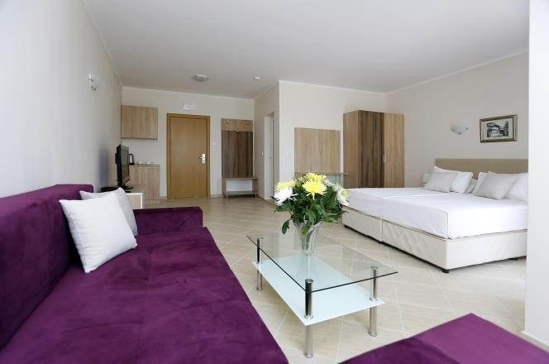
Studio – 35 m², equipped with one double bed, sofa bed, bathroom with shower cabin, TV, individually adjustable air conditioner, Wi Fi, small fridge, kettle and cups, balcony with terrace furniture and drying rack. Minimum capacity - 2, maximum capacity – 2+1 people.

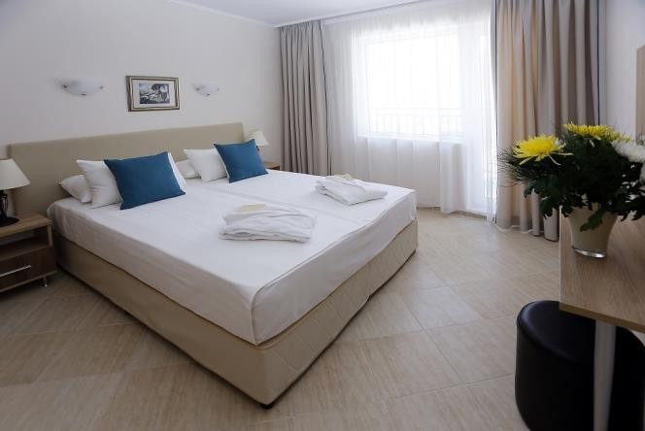
Apartment with one bedroom – 50 m², consisting of bedroom and living room. There is one double bed in the bedroom and twin beds in the living room. The apartment is equipped with one bathroom with shower, TV and individually adjustable air conditioner in the living room, Wi Fi, small fridge, kettle and cups, balcony with terrace furniture and drying rack. Minimum capacity - 2, maximum capacity – 2+2 or 3+1 people.

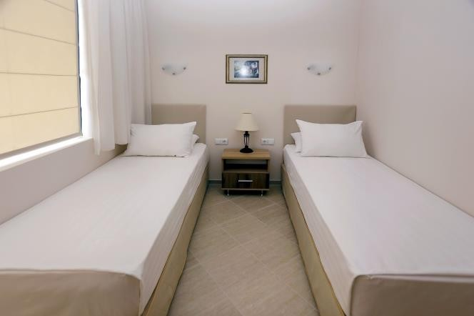
Apartment with two bedrooms – 65 m², consisting of two bedrooms and living room. In the first bedroom there is a double bed, and in the second – twin beds. In the living room there is a sofa bed. The apartment is equipped with two bathrooms with shower, TV and individually adjustable air conditioner in the living room, Wi Fi, small fridge, kettle and cups, balcony with terrace furniture and drying rack. Minimum capacity - 2+2, maximum capacity – 4+1 people.

Sunrise River Beach Resort offers accommodation and all-inclusive light board. The package service includes:
- Sunbeds and parasols by the pools upon availability;
- Buffet breakfast with hot and soft drinks included (08:00 – 10:00), lunch (12:00 – 14:00) and dinner (18:00 – 20:00) with soft drinks, draft beer and wine included;
- Afternoon snack at the snack bar from 15:00 until 17:00;
- Daily entertainment for adults and children from 3 years, evening entertainment until 22:30;
- Internet in the apartments, at the reception area and by the pool bar.

Extra services against charge:
- Safe deposit box – BGN 5.00/day and package prices for long stay (the safes are located at the reception);
- Bicycles, scooters and car rental;
- Massages.

Important information:
- Check-in: after 14:00, check-out – until 12:00;
- Bed linen change – every 7 days;
- Towel change – every 4 days;
- Baby bed – free of charge, advance request is required;
- To use the all-inclusive package all guests must wear a bracelet during their stay. The package starts with lunch or dinner on the arrival day and ends with breakfast or lunch on the departure day.
- Pets up to 4 kg are allowed against charge (BGN 30.00/day), but they are not allowed in the dining areas.

