Hotel SENTIDO Marea is totally renovated in 2016/2017 with a new, modern vision and enriched product offering 24 hours service. The hotel is located in the peaceful and quite part of the resort right on the promenade with stunning vistas of the Black Sea. The hotel attract its guests with the very wide, fine and clean sandy beach. This makes the place perfect for vacation with little children.

Highlights and new services
- NEW: A-la-cart dinner – limitation of free access to the a la carte restaurant by the duration of stay:
- Stay up to 3 nights incl. –a la carte dinner is not included
- Stay of 4 and 5 nights incl. – one a la carte dinner is included
- Stay of 6 nights and more – unlimited access
Advance reservation is required for all a la carte dinners
- One parasol and two sun beds (with mattresses) per room on the beach, UPON AVAILABILITY
- A la carte restaurant with Bulgarian cuisine presented with two different menus: modern and traditional presentation of Bulgarian cuisine;
- Premium room – high floor, direct sea view, upon availability early check-in & late check-out, capsule coffee machine (refilled daily), “Rituals” bath amenities, bathrobe and slippers; welcome gift;
- For PREMIUM GUESTS: One a la carte dinner in “Beach Club” by Grifid (once per stay; reservation required and price included with minimum stay required;
- For PREMIUM GUESTS: Free access to the exclusive beach zone with Snack restaurant as well as Beach bar Encanto beach (drinks between 10:00 – 23:00 o’clock);
- NEW: free in-room safe
- NEW: Well-fit zone on an open-air roof terrace;
- NEW: renovated beach bar and lounge zone;
- NEW: prolonged working hours and new SNACK concept of Food truck (snack right on the beach)

General information
- 24 Hours ULTRA All inclusive basis
- Two buildings: 9 and 6 floors
- 10 m from the beach
- 15 km from Varna
- 30 km from Varna Airport
- 1000 m from the center of the resort
- 800 m from the shopping center
- 1700 m from a public bus station
- Languages spoken: Bulgarian, English, German, French, Russian
- 24-hours reception & 24 hours security
- Concierge services – taking care of all little details that matter for your stay
- Main restaurant, a la carte restaurants “Food of Bulgaria”, Food Truck snack on the beach, Coffee shop, Midnight Snack
- Lobby bar, Pool bar, Blue bar offers variety of local and international alcoholic and non-alcoholic beverages. Beach bar offers only local ones.
- Parking – limited and against charge
- Free Wi-Fi connection in hotel lobby area and in the rooms
- Taxi & Rent-a-car services
- Laundry and ironing service – at a charge
- Currency exchange
- Doctor
- Gym, Wellness & Relax center
- Animation hall and open air stage for entertainments
- Entertainment, sport activities and animation program for adults & children
- Grifid Aqua Park (located in a Grifid Club Hotel Bolero) operates between June-September (weather depending), free of charge access ONLY for guests have reserved Family rooms! Separated sections for kids and adults. Height requirement for adults section – min. 1.40 m.
- Certificated by Travelife
Accommodation
- Check-in time – from 14:00h – starts with afternoon snack menu
- Check-out time – until 12:00h – ends with late continental breakfast
- 2017 complete renovation of the hotel
- 298 rooms in total from which double rooms with park view and sea view, as well as comfortable family rooms for bigger families
- All rooms are with bathrooms with shower
- All rooms are with laminated floor
- Hairdryer and cosmetic mirror
- International dialing phone
- Central air conditioning system
- Satellite TV
- Free Wi-Fi connection
- In-room safe (free of charge)
- Mini bar – free of charge, daily restocked /water, soft drinks, beer/
- Balcony
- Tea & Coffee facilities in all rooms /daily refilled/
- Pillow menu
- Top mattress menu – upon request
- Baby cots – free of charge
The early check-in and late check-out are according the availability of the hotel and are a subject of additional payment.
MAREA PREMIUM rooms
  - Located always on upper floor with frontal sea view
  - Slippers and bathrobes
  - Branding toiletries “RITUALS”
  - Capsules coffee machine (refilled daily)
  - Welcome gift packet on arrival
  - Priority check –in and option for complimentary late check-out upon availability
  - Dinner at the BEACH CLUB a la carte restaurant (once per stay; advance reservation required; included with minimum stay required )
  - Exclusive access to special designated beach zone with service (10.00 – 23.00h)
  - Afternoon snack at the BEACH CLUB Encanto
  - Dedicated concierge to assist with planning vacation experience and booking reservations – dinner / spa / special occasion celebration;
  - Nordic walking and adventure tour to National park of Golden Sands with
  - Fitness, Yoga and swimming lessons (against charge)
  - 15% discount for one treatment in MediSpa Encanto beach
Restaurants – part of ULTRA All inclusive basis

Main Restaurant
Modernly furnished hall with belonging open-air terrace.
Opening hours:
Breakfast 07:30 – 10:00 buffet
Continental breakfast 10:00 – 12:00 table service
Lunch 12:30 – 14:00 buffet
Dinner 18:00 – 21:00 buffet
Midnight snack 23:30 – 00:30
- Capacity: 300 indoor seats and 90 outdoor ones on the terrace
- Buffet breakfast, lunch, dinner and midnight snack
- Table service for continental breakfast
- Healthy buffet
- Varied culinary delights offered via show cooking, carving, pizza and pasta stations; salad and delicious pastry buffets
- Beverage buffet with mineral water, soft drinks, draft beer and country wine; smoothies for breakfast in particular
- Highchairs for children
- Culinary theme buffets – 2 times per week
- Designated adults only zone
- Nonsmoking inside

A la carte restaurant “Food of Bulgaria”
Situated on the ground floor and offers Bulgarian cuisine in modern ambience

Opening hours:
Dinner 18:30 – 21:30 table service
- Capacity: 80 seats
- A la carte service and traditional Bulgarian menu for dinner
- Beverages - mineral water, soft drinks, draft beer and country wine
- included with minimum stay required
- Children menu & highchairs
- Smoking is not allowed
Dress code for dinner required – long trousers for gentlemen
Food Truck – snack right on the beach
Opening hours:
11:30 – 17:00 – with earlier opening, before lunch time
- Special and new SNACK Concept
- Bar service

Bars – part of ULTRA All inclusive basis

Lobby Bar
The bar delivering beverages to the elegant salon of the lobby bar with fascinating view to the sea.
Opening hours:
00:00 – 24:00
- Smoking is not allowed
- Ultra All inclusive offer features mineral water, international and local alcoholic beverages, non-alcoholic beverages and refreshing cocktails, coffee and tea, draught beer and country wine
- Bar service

Pool Bar
Opening hours:
10:00 – 19:00
- Ultra All inclusive offer features mineral water, international and local alcoholic beverages, non-alcoholic beverages and refreshing cocktails, coffee and tea, draught beer and country wine
- Bar service
Beach Bar – renovated and enriched with lounge zone
Opening hours:
10:00 – 17:00
In high season 09:00 – 18:00

- Ultra All inclusive offer features mineral water, local alcoholic beverages, non-alcoholic beverages and refreshing cocktails, coffee and tea, draught beer and country wine
- Bar service
Blue Bar
Opening hours:
15:00 – 23:00

- Ultra All inclusive offer features mineral water, international and local alcoholic beverages, non-alcoholic beverages and refreshing cocktails, coffee and tea, draught beer and country wine
- Bar service
Pastry shop
Opening hours:
14:30 – 17:00

Swimming pools and Wellness center
Outdoor pool:
Opening hours:
09:00 – 18:00
- Sun terraces by the pools
- Complimentary sun lounges, parasols and towels
- Life guard service provided

Indoor pool:
Opening hours:
09:00 – 18:00
- Classic pool
- Heated
- Complimentary sun lounges and towels
- Life guard service provided
Kid’s MINI aqua park
Opening hours:
09:00 – 18:00
- 40cm depth of the pool
- Sun terraces by the pool
- Complimentary sun lounges, parasols and towels
- Life guard service provided

Beach services included

One parasol and two sun beds (with mattresses) per room on the beach upon availability (only full-paying customers)!

Children, accommodated free of charge, don’t receive the above services!

Wellness and Relax
The modern Relax center of the hotel offers treatments that will revitalize the body and the soul
Opening hours:
09:00 – 18:00
All treatments: sauna, Hammam, treatments in Beauty salon are additionally charged!
- Hammam with steam bath, sauna, hydro massage bath
- Relax zone
- Hairdresser, manicure and pedicure
- Massage rooms; facial and body treatments and range of spa treatments
- Body and face cosmetic

Sport & Animation activities

FIT & FUN Zone
Opening hours:
06:00 – 20:00
- Fitness room with professional equipment by Technogym;
- Air conditioning
- Free access for all hotel guests
- Well-fit zone on an open-air roof terrace
WELL FIT ACTIVITIES
- Gymnastics, Aerobics, Pilates, Zumba, Yoga
- Table tennis
- Beach volleyball
- Aqua gym, Aqua Jogging, Water polo
- Darts
- Bicycle tours
Evening shows – daily
Theme events – beach parties (July- August)
Mini club with daytime entertainment program for children:
Opening times:
10:00 – 12:30
15:00 – 17:30
- For children aged 4 to 12
- Mini disco – every day
- Children show once in 2 weeks
- Theme days and activities
- Kids mini aqua park with 40cm depth

Rooms
- Economy room: app. 28 m2, 2+0.
- Double room with park / sea side / sea view: app. 30 m2. 2+0, 2+1, 3+0.
- Premium room: app. 30 m2, 2+0, 2+1, 3+0. Bathrobes, slippers in the room. Coffee machine. Separate WC and bathroom
- Family room with park view: app. 40 m2. 2+2, 3+1.
- Family room with sea view: app. 45 - 50 m2. 2+2, 3+1.

Paid Services
- Parking lot – limited
- Rent a car
- Spa treatments in wellness center
- Services in beauty salon
- Wine selection in all restaurants
- Baby sitter services (for children at least 4 years old)
- Baby buggies & baby phone (on request)
- Bicycle (when not part of the animation bicycle tour)
- Transfer from and to Varna airport
Miscellaneous
- Pets are not admitted
- Hotel reserves the right to change opening hours of the outlets, if necessary.
- Under Bulgarian legislation it is not allowed to smoke in the hotel lobby, restaurant, bars and rooms (indoors)
- Sun bed reservation is not accepted. Any unattended towels are removed from the pool and beach staff
- Any food and drinks could not be taken out of the restaurants due to Public and HACCP regulations

Contacts
Tel.: +359 52 383 000 (Hotel Reception)
Web site: www.grifidhotels.com
PHOTOS available at: https://sentidomarea.pixieset.com/sentidomarea/
Covid-19 Safety and hygiene measures available at: https://grifidhotels.com/index.php?page=covid19health

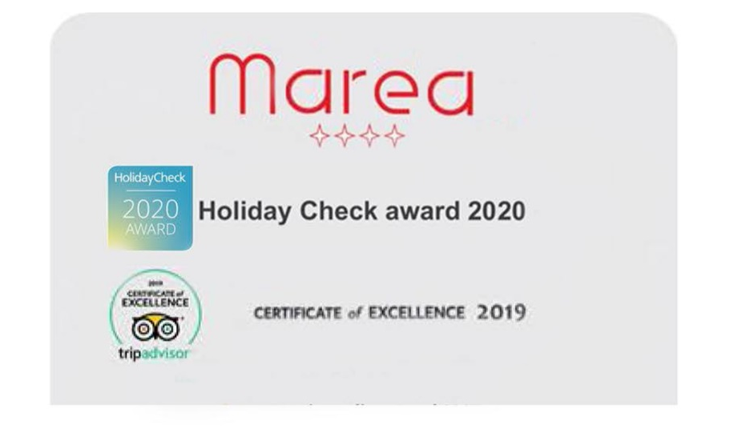
Awards

