Umani Hotel & Beach 4*, Golden Sands, 2023

Website: https://hotelumani.bg/

HOTEL POLICIES
Check-in time | After 14:00 on the day of arrival.
Check-out time | 12:00 upon day of departure.
Smoking | Smoking is not allowed.
Pets | No pets allowed

About Umani Hotel & Beach, Golden Sands

HOTEL DETAILS
Number of rooms | 52 rooms & suites
Star rating (official) | 4*
Number of floors | 5 + underground level
Elevators | 2 within the hotel, 1 at the outdoor parking
Pool | Seasonal outdoor pool, sunbeds & umbrellas, free of charge for hotel guests (10..5 x 3.3 m); no child section;
Parking | Outdoor and underground parking options available, free of charge for hotel guests with limited spaces (upon availability at time of arrival); additional free option for parking on the street in front of the hotel;
Internet | Free Wi-Fi available in the rooms and public areas
Restaurant | Sea Salt Restaurant: the main restaurant, with indoor and open-air searing, located at lobby level, offers international cuisine. Serves breakfast, lunch and dinner, and a class selection of wines, beer and spirits.
Bars | The Concept Lobby Bar, Pool Menu available
Room Service | Available
For Kids | Please note that the hotel may not be the best choice for families with babies or toddlers due to the landscape and denivelation of the area. The beach is accessible via a trail with stairs, with no ramp for strollers. The hotel yard is on a hill, with the outdoor pool accessible via stairs or with the lift through the underground parking.
Accessibility | The hotel offers an accessible guest room, however the property and the nearby Umani Beach are not suitable for wheelchair and stroller access.
Beach | Umani Beach is located 250 m away and offers free sunbeds and umbrellas to Hotel Umani guests (1 umbrella per room and 1 sunbed pre person included in the rate). Access to the beach is via a path with 50-m stairs, thus not suitable for wheelchairs, strollers and physically challenged persons.

Umani Hotel & Beach is located in a quiet area of the South part of Golden Sands resort, Bulgaria, where the guests can enjoy both the lively spirit of the resort, and the tranquility of the surrounding trees and sea. Inspired by nature, Hotel Umani is designed for the ultimate comfort and relax. The name ‘Umani’ means ‘humans’ in Italian, and was precisely selected among all options as the unity of our concept is devised entirely around the guest experience.

Open in 2022, the 4* hotel offers 52 elegant rooms and suites with relaxed and natural ambiance, and captivating design. The sea view rooms reveal a fantastic panorama. The contemporary and inspiring architectural design was immediately recognized and the project received seven awards, among which are Winner of the American Architecture Prize and Interarch XIV World Triennial of Architecture, silver medal, and Building of the year Bulgaria 2022 in category Holiday and Spa Hotels.

All rooms offer free Wi-Fi, a Nespresso machine, minibar, flat screen TV, air conditioning, safe box, and a balcony. Our guests are welcome to enjoy free of charge sunbeds and umbrellas at Umani Beach, outdoor seasonal pool (10.5 x 3.3 m, max depth 1.5 m), and free parking (upon availability at arrival).
Treat yourself to a culinary journey with our selection of local, Mediterranean and international dishes, hand-picked fish and seafood meals, wines, craft beers and more. The hotel features one restaurant in the hotel, a concept lobby bar, and selected pool menu for the outdoor pool.

ROOM DETAILS

Room Type | Double Room – Sea View | Double Room – Pool Side | Double Room – Park View
Photos | 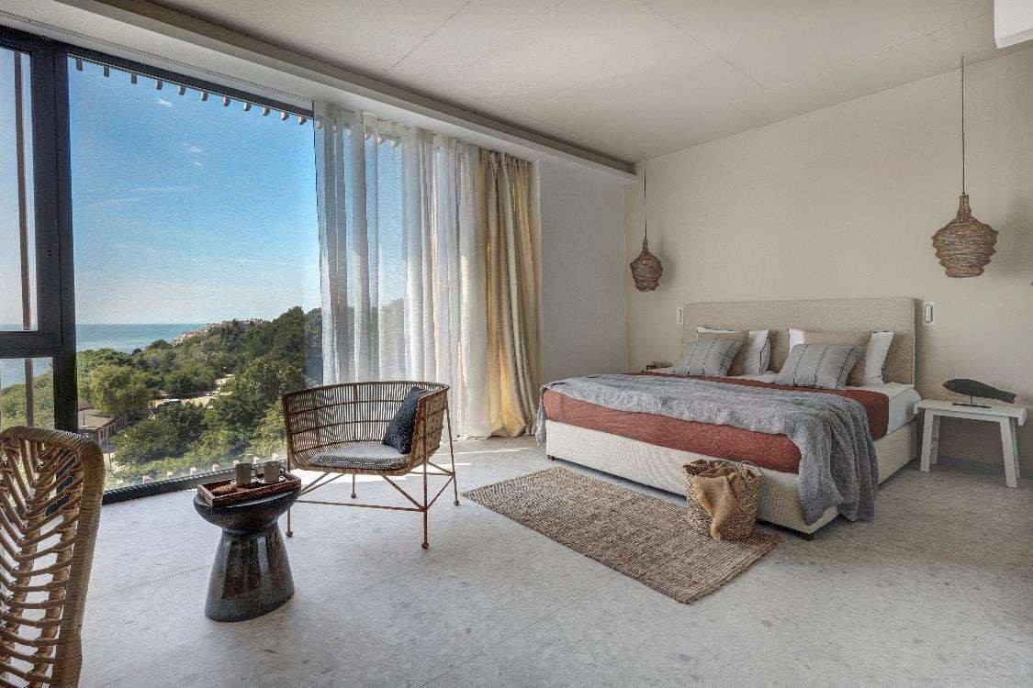 | 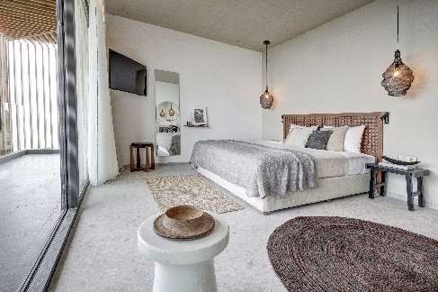 | 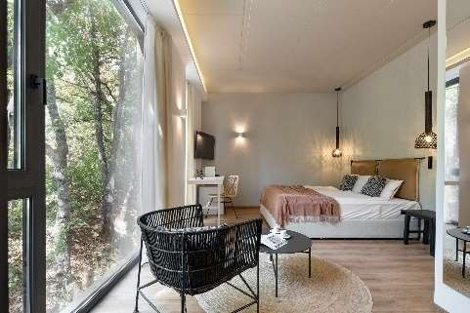
Size: | 33 sq.m. | 33 sq.m. | 28 sq.m.
View: | Sea | Park (Pool side) | Park
Capacity (max) | up to 4 guests, max. 3 adults + 1 child or 2 adults + 2 children | up to 4 guests, max. 3 adults + 1 child or 2 adults + 2 children | 2 adults
Beds: | 1 king size bed (1.80 x 2.00 m) OR  1 king size bed (1.80 x 2.00 m) and 1  extendable double sofa (1.40 x 1.90 m) | 1 king size bed (1.80 x 2.00 m) OR  1 king size bed (1.80 x 2.00 m) and 1  extendable double sofa (1.40 x 1.90 m) | 1 king size bed (1.80 x 2.00 m)
Bathroom: | 1 bathroom with shower and hair dryer | 1 bathroom with shower and hair dryer | 1 bathroom with shower and hair dryer
Room essentials for all room types:
 | Free Wi-Fi
 | Nespresso coffee machine
 | Minibar
 | Flat screen TV 43’’
 | Air conditioning
 | Safe deposit box
 | Balcony

DOUBLE ROOM – SEA VIEW

Beautifully appointed spacious boutique rooms offering various designs, for up to 4 guests, and a stunning Sea view. Ideal for both couples and families, the rooms offer a king size bed (1.80 x 2.00 m), with some rooms featuring an extendable double sofa (1.40 x
1.90 m). All rooms have a spacious balcony, free WiFi, a flat screen TV, a safe deposit box and a minibar. The bathroom is equipped with a shower, a toilet and a hair dryer. For your fresh mornings, a Nespresso coffee machine is available.

DOUBLE ROOM – POOL SIDE

Modern and spacious boutique rooms offering a variety of designs, for up to 4 guests (2 adults and 2 children up to 11 years). The rooms are at the sea side of the hotel, located above the outdoor pool, and on the first floors of Hotel Umani.
Ideal for both couples and families, the rooms offer a king size bed (1.80 x 2.00 m), with some rooms featuring an extendable double sofa (1.40 x 1.90 m). All rooms have a spacious balcony, free WiFi, a flat screen TV, a safe deposit box and a minibar. The bathroom is equipped with a shower, a toilet and a hair dryer. For your fresh mornings, a Nespresso coffee machine is available.

DOUBLE ROOM – PARK VIEW

Enjoy a cozy Park view room, offering a king size bed (1.80 x 2.00 m), free WiFi, a flat screen TV, a safe deposit box, a minibar and a balcony. Maximum occupancy is 2 adults. The bathroom is equipped with a shower, toilet and a hair dryer. For your fresh mornings, a Nespresso coffee machine is available.

ADDITIONAL SERVICES – ALL ROOM TYPES

- Free of charge sunbeds & umbrellas at Umani Beach*
- Free outdoor pool access & sunbeds
- Free parking option for guests, upon availability at arrival
- Beach towels upon request
- Quality toiletries
- Wake-up service
- Room Service – extra charge
- Laundry & ironing options – extra charge
- Transfers & excursions – extra charge

*One beach umbrella per room and one sunbed per person.

PLEASE NOTE: Our rooms are with boutique design and feature different styles, furniture and arrangements. Please specify any preferences you may have at time of booking – we will do our utmost to suit your requirements, however it will be subject to availability. As the hotel is usually quite busy, it may not be possible to adhere to your requests, especially if made upon arrival.

