FACT SHEET SEASON 2022

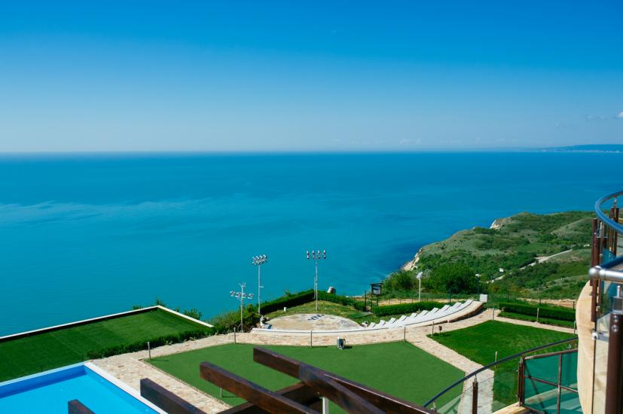

General Facilities & Services
Situated above one of the most beautiful Black Sea bays, among picturesque coastal hills, with fabulous views of the endless waters of the Black Sea - holiday complex Topola Skies Resort & Aquapark is a dream location for a relaxing family vacation.
Topola Skies is situated in one of the most picturesque places on our Black Sea coast, about 60 km north of Varna and about 17 km south of cape Kaliakra. Nearby are the three greatest golf courses in Bulgaria, as well as bay “Bolata” which falls in the ranking of, “The most beautiful bays in the world”.
Topola Skies combines luxury and nature. The complex offers spacious and fully furnished apartments and hotel rooms. The guests have at their disposal three heated pools, Wellness and Relaxation Centre and unique DREAM SPA center, recreating an authentic Bulgarian atmosphere.

Total number of rooms and apartment: 368  Number of Restaurants: 3  Number of Bars: 4  Number of Elevators: 4  Free Wi Fi Connection in Public Areas  Free Wi Fi Connection in Conference Area  Free Wi Fi Connection in all guestrooms  *Non-smoking rooms and apartments  *No pets allowed | Additional services (extra charge):  - Zip line - additional charge  - Doctor on call  - Rent-a-Car;  - Bike Rental  - ATM  - Laundry and dry cleaning  - Mail services  - Grocery and souvenir shop  Additional services  - Bellboy  - Shoe shine service  - Machine Wake up calls  - Outdoor parking area – 218 places  - Outdoor parking Aquapark – 184 places

Rooms and apartments

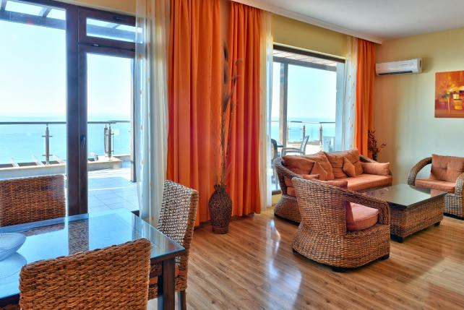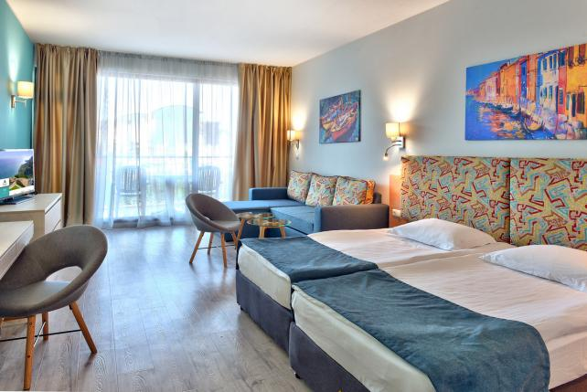

Standard room with pool view: 115  - Approx.: 35 sq.m.  Standard room with sea view: 78  - Approx.: 35 sq.m.  Room Deluxe with sea view: 24  - Approx.: 35 sq.m.  Apartment with one bedroom pool view: 73  - Approx.: 60 sq.m.  Apartment with one bedroom sea view: 60  - Approx.: 60 sq.m.  Deluxe apartment with one bedroom sea view: 21  - Approx.: 60 sq.m.  Apartment with two bedrooms pool view: 12  - Approx.: 80 sq.m  Deluxe Apartment with two bedrooms sea view: 9  - Approx.: 80 sq.m | General Room Amenities  - Balcony with table and chairs  - Air Condition and heating  - Electronic Key Card System  - Table and armchairs  - Cable TV with remote control  - Wi-Fi internet connection (free of charge)  - Electric water kettle  - Refrigerator
Bathroom

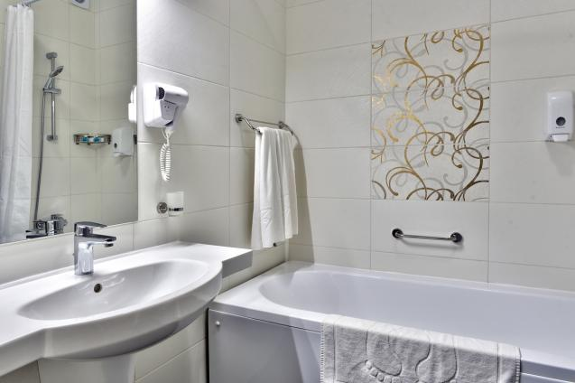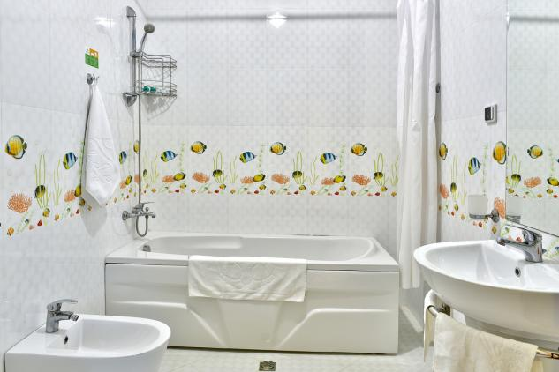

- Bidet (available in apartments, in build in all rooms)  - Hairdryer  - Bathtub with shower | - Mirror  - Shampoo and shower gel  - Bath salts
Restaurant & Bars

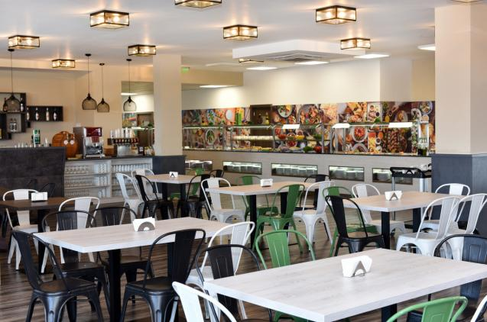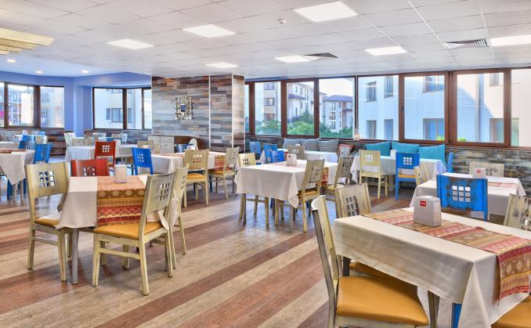

Main Restaurant - 2  Number of seats: 1200 (2 floors)  Restaurant type: Buffet-style restaurant  Cuisine type: International  Breakfast / Lunch / Dinner  - Salad buffet  - Pastry buffet  - Kids food corner  - Bread station - Cold and hot meals  - Show cooking station | The Bistro  Number of seats: 250  Restaurant type: Private function venue operates with advanced reservation.  Cuisine type: International, lunch and dinner  Lobby Bar  Restaurant type: Lobby Bar  Number of seats: 60  3 Pool Bars  Number of seats: 180  Restaurant type: Pool Bar
Conference rooms
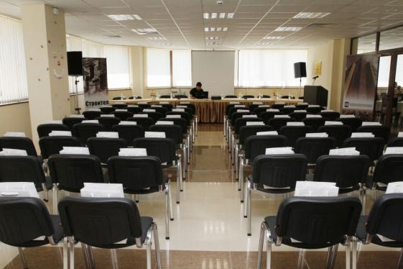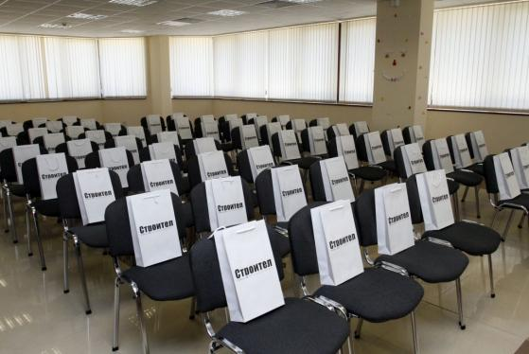

Meeting Hall 1  120sq.m., 3.0 m. height; 120 pax theater style  Meeting Hall 2  120sq.m., 3.0 m. height; 120 pax theater style  *Extra charge | Conference Services:  Equipment Rental*  - Audio-Visual-Equipment  - Flipchart  - Free Internet Connectivity via Wi-Fi  - Wireless Microphones  - Monitor  - Screen  - Sound Equipment

Swimming pools

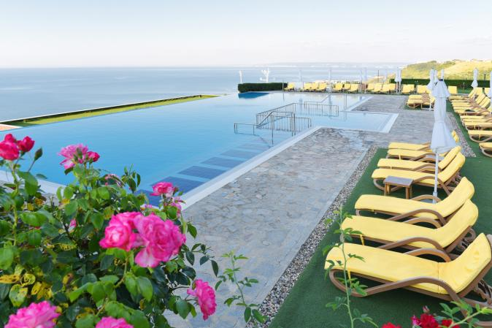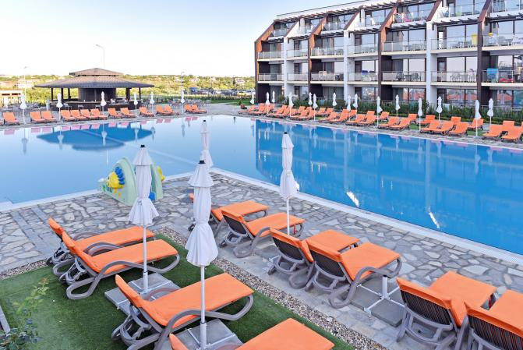

- Infinity pool: 25 х 10 m size depth - 1,20 m - 1.60 m;
- Two level swimming pool: 31 х 20 m size depth - 1,20 m - 1.60 m;
- Swimming pool with kids zone: 30 х 16 m size depth - 0.60 - 1,60 m;
- Indoor swimming pool: 14 х 6 m size depth - 1,20 m - 1.60 m;

SPA and wellness center

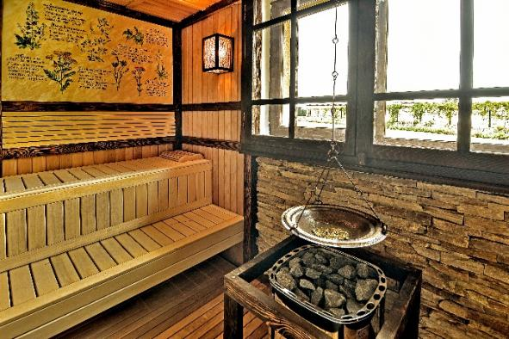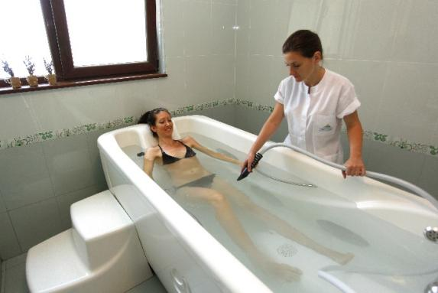

Wellness Center  - Steam bath  - Contrast shower  - Relax zone  - Table Tenis  - Fitness room | Dream SPA  * additional charge apply  - Steam bath  - Finnish and herbal sauna  - Salt room (subject to additional payment)  - Ice room  - Adventure cave  - Relax zone  -SPA therapies | VIP SPA Suite  * additional charge apply  - Classic massages, peelings and spa ritual  - Aromatherapy  - Anti-cellulite and slimming therapies  - Cleaning, firming and rejuvenating  facial treatments  - Detox therapies  - Herbal and citrus massage  - Hydro massage and aromatic baths

Aquapark

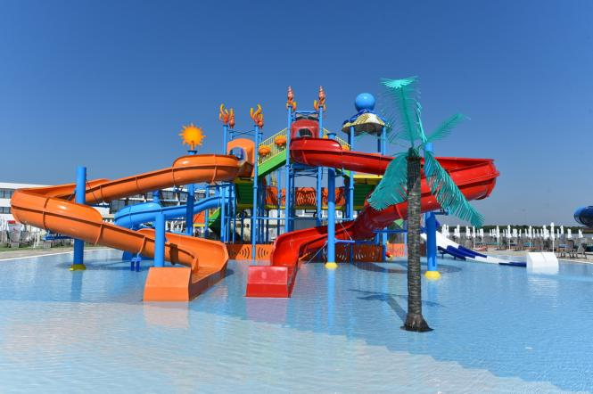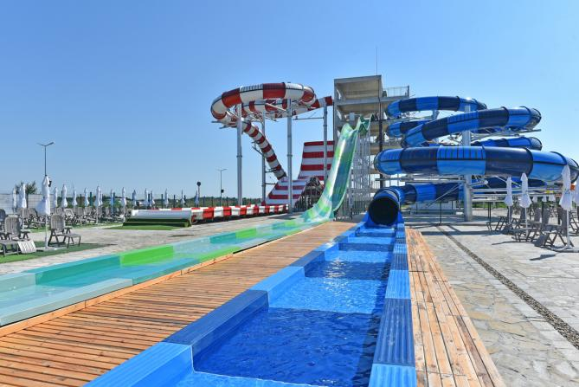

Aquapark - 9700 sq.m size  -"Aqua tube" - lenght 70 m.  - "Free fall" - lenght 50 m.  - "Black hole'' - lenght 142 m.  - "Thunder cruise'' - lenght 75 m.  - "Turbolance" - lenght 66 m.  Action park  The Action park is entertainment and extreme activities ropes park with two levels of difficulty. The action park is equipped with two climbing walls with 8 meters height  Level 1  Level one rope route consists of 10 hurdles, directed for kids above 8 years of age. This route is advised for all beginner levels. The end of this level is zip lining from 2.50 meters height.  Level 2  Level two rope route consists of 11 hurdles, directed for kids above 12 years of age. This route is slightly harder and it requires certain physical form and techniques. The height is a major factor, in this second level, because the participants are at 5 meters altitude. | Kids water castle  size 23 x 21 m., height 10 m.  Swimming pool with artificial waves  water area: 402 m2  Available to all hotel guests  *From 15th June to 10th September  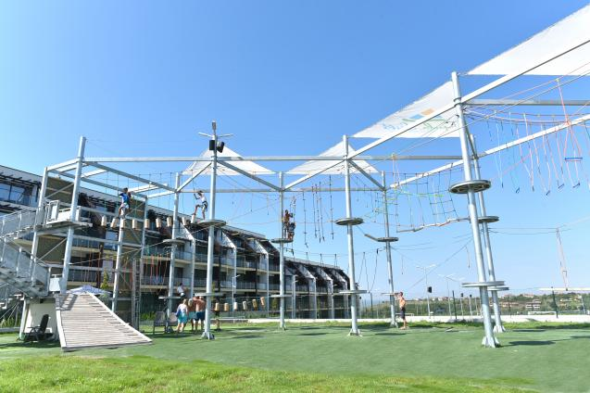

Sports Activities
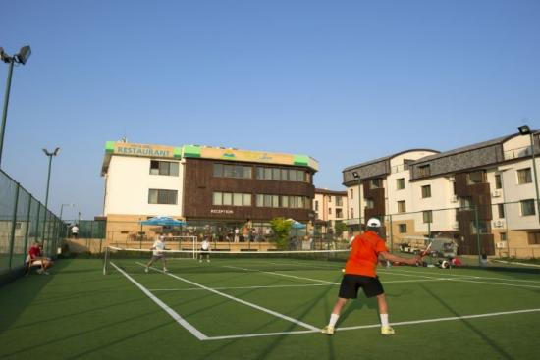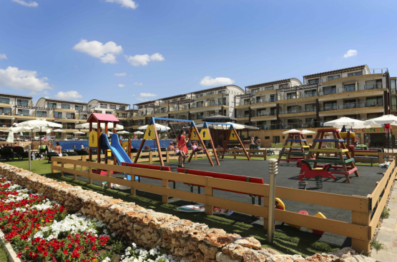

In-house:  - Tenis courts  - Badmington  - Pool  - Volleyball  - Mini football  - Billiard | - Darts  - Chess  - Table Tennis  - Fitness center  - Kids playground  - Shopping

Safety & Security

- Hotel meets fire safety code
- 24 Hour security
- Uniformed security
- Audible alarms in public areas, hallways and bedrooms
- Video surveillance entrance, hallways and public areas
- Smoke detectors in hallways, public areas and bedrooms
- Fire extinguishers in hallways
- Fire detectors in public areas, hallways and bedrooms
- Emergency lighting

Distance to Important locations

Varna Airport - 60 km
Varna Train Station - 55 km

Points of Interest
- Historic downtown of Balchik - 13 km
- Balchik Palace and Botanical Garden - 12 km
- Cape Kaliakra - 22 km
- Thracian Cliffs golf course - 0.7 km
- Black Sea Rama golf course - 6 km
- Lighthouse golf course - 8 km

