StayInn Banderitsa Apartments

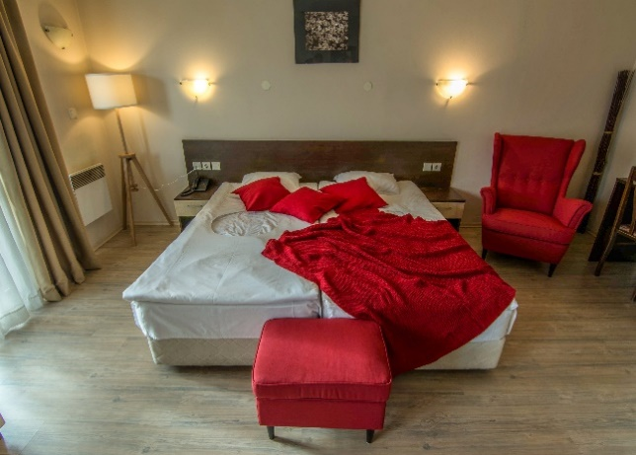
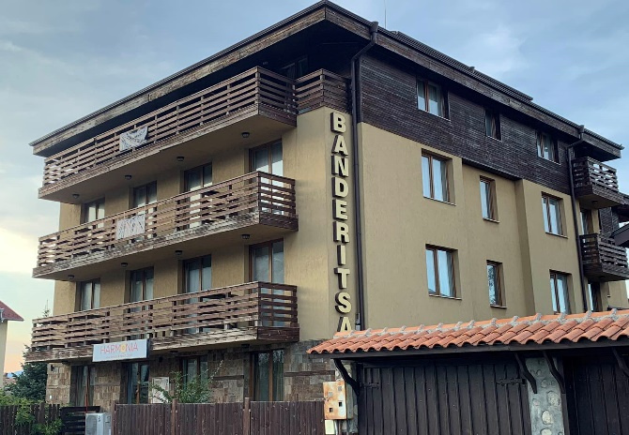

StayInn Banderitsa Apartments is a complex with 7 apartments and 5 studios, offering perfect conditions for year-round holidays in the mountains in the ski resort Bansko. It features a convenient location, 5-minute walk from the Old town and 900 meters from the gondola lift, set at almost equal distance from the town top center, the ski area and the main road.
All apartments have a living room with sofa TV, separate bedroom, superb views of the Pirin Mountain and a fully equipped kitchen with everything needed for cooking your favorite meals. Free Welcome packs for the guests including coffee, tea, and bottled water. The accommodation is ideal for skiers but will also make a wonderful base for those wishing to enjoy the winter sights in and around Bansko.
You can use the SPA center with sauna, Jacuzzi, steam bath, massage, gym and all additional provided services in our nearby hotel Asteri. Breakfast, lunch and dinner are also available upon request. Ski storage is provided with ski equipment rental service. During the winter season a shuttle bus is available to our guests from our properties to the ski lift and to our other property in Bansko Hotel Asteri, every 30 min.
Thanks to our cooperation with StayInn part of Asteri Hotels chain, we offer a professional and very high level of service. We have a daily working reservation center, which contributes to the fast processing of reservations and inquiries from travel agencies, corporate partners, direct customers and personal relationships.
We believe that we are on the right track and this makes us work with even more effort to drive desire and very positive energy, learn and improve, so that we can offer the best accommodation services to all of you.

