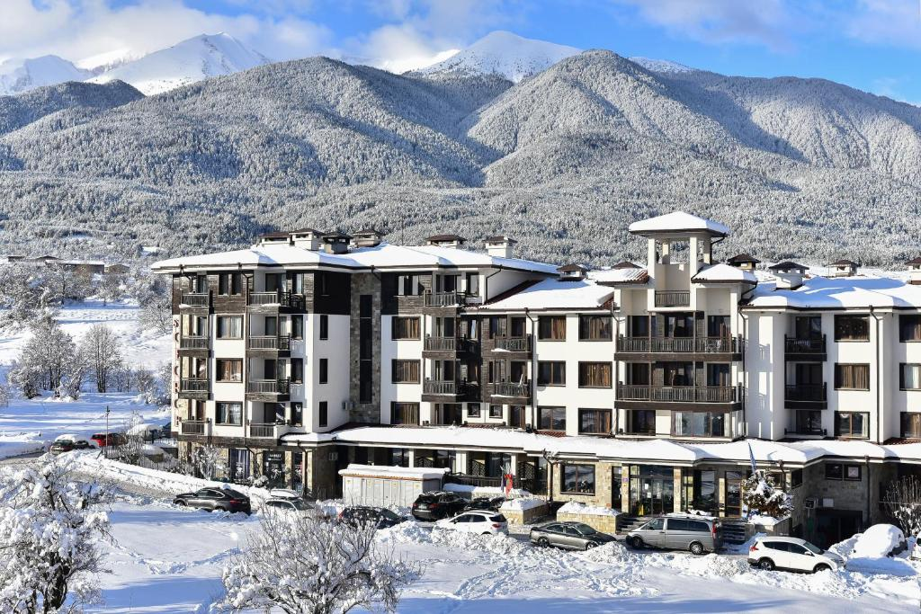

ST. GEORGE SKI & HOLIDAY 4*
Ski holidays, spacious apartments and spa relaxation at the foot of the Pirin Mountains
St. George Ski & Holiday 4* is a four-star spa aparthotel in Bansko, open all year round. Set at the foot of the Pirin Mountains, it is approximately 400 m from the gondola base station and within walking distance of the town centre. The hotel offers spacious double rooms, studios and one-, two- and three-bedroom apartments, suitable for families with children, couples and groups.
All rooms and apartments have a private balcony. Many balconies offer panoramic views of the Pirin, Rila and Rhodope Mountains.
Double rooms, studios and apartment living areas are equipped with Smart TVs, while apartment bedrooms have LCD TVs.
Guests can enjoy a spa and wellness centre with an indoor heated swimming pool at 32–33°C, a hot tub at 36°C, saunas, a steam room, a Turkish bath, a salt room, a fitness centre and a relaxation area with heated loungers — an ideal place to unwind and recover after an active day in the mountains.
Dolce Vita Restaurant serves delicious home-cooked food made with selected local ingredients, traditional specialities and themed dinners. Guests can choose Bed & Breakfast (BB), Half Board (HB) or All Inclusive (AI), depending on their package.
The hotel offers free outdoor parking, free Wi-Fi, a free safe at reception, a children’s play area with entertainment, and free storage for guests’ own ski and snowboard equipment. During the winter season, guests can use the complimentary scheduled shuttle service to and from the gondola base station.
St. George Ski & Holiday 4* is an excellent choice for skiing and snowboarding holidays in Bansko in winter, as well as family breaks, mountain walks, hiking and cycling in the Pirin Mountains in spring, summer and autumn.

Accommodation Photos
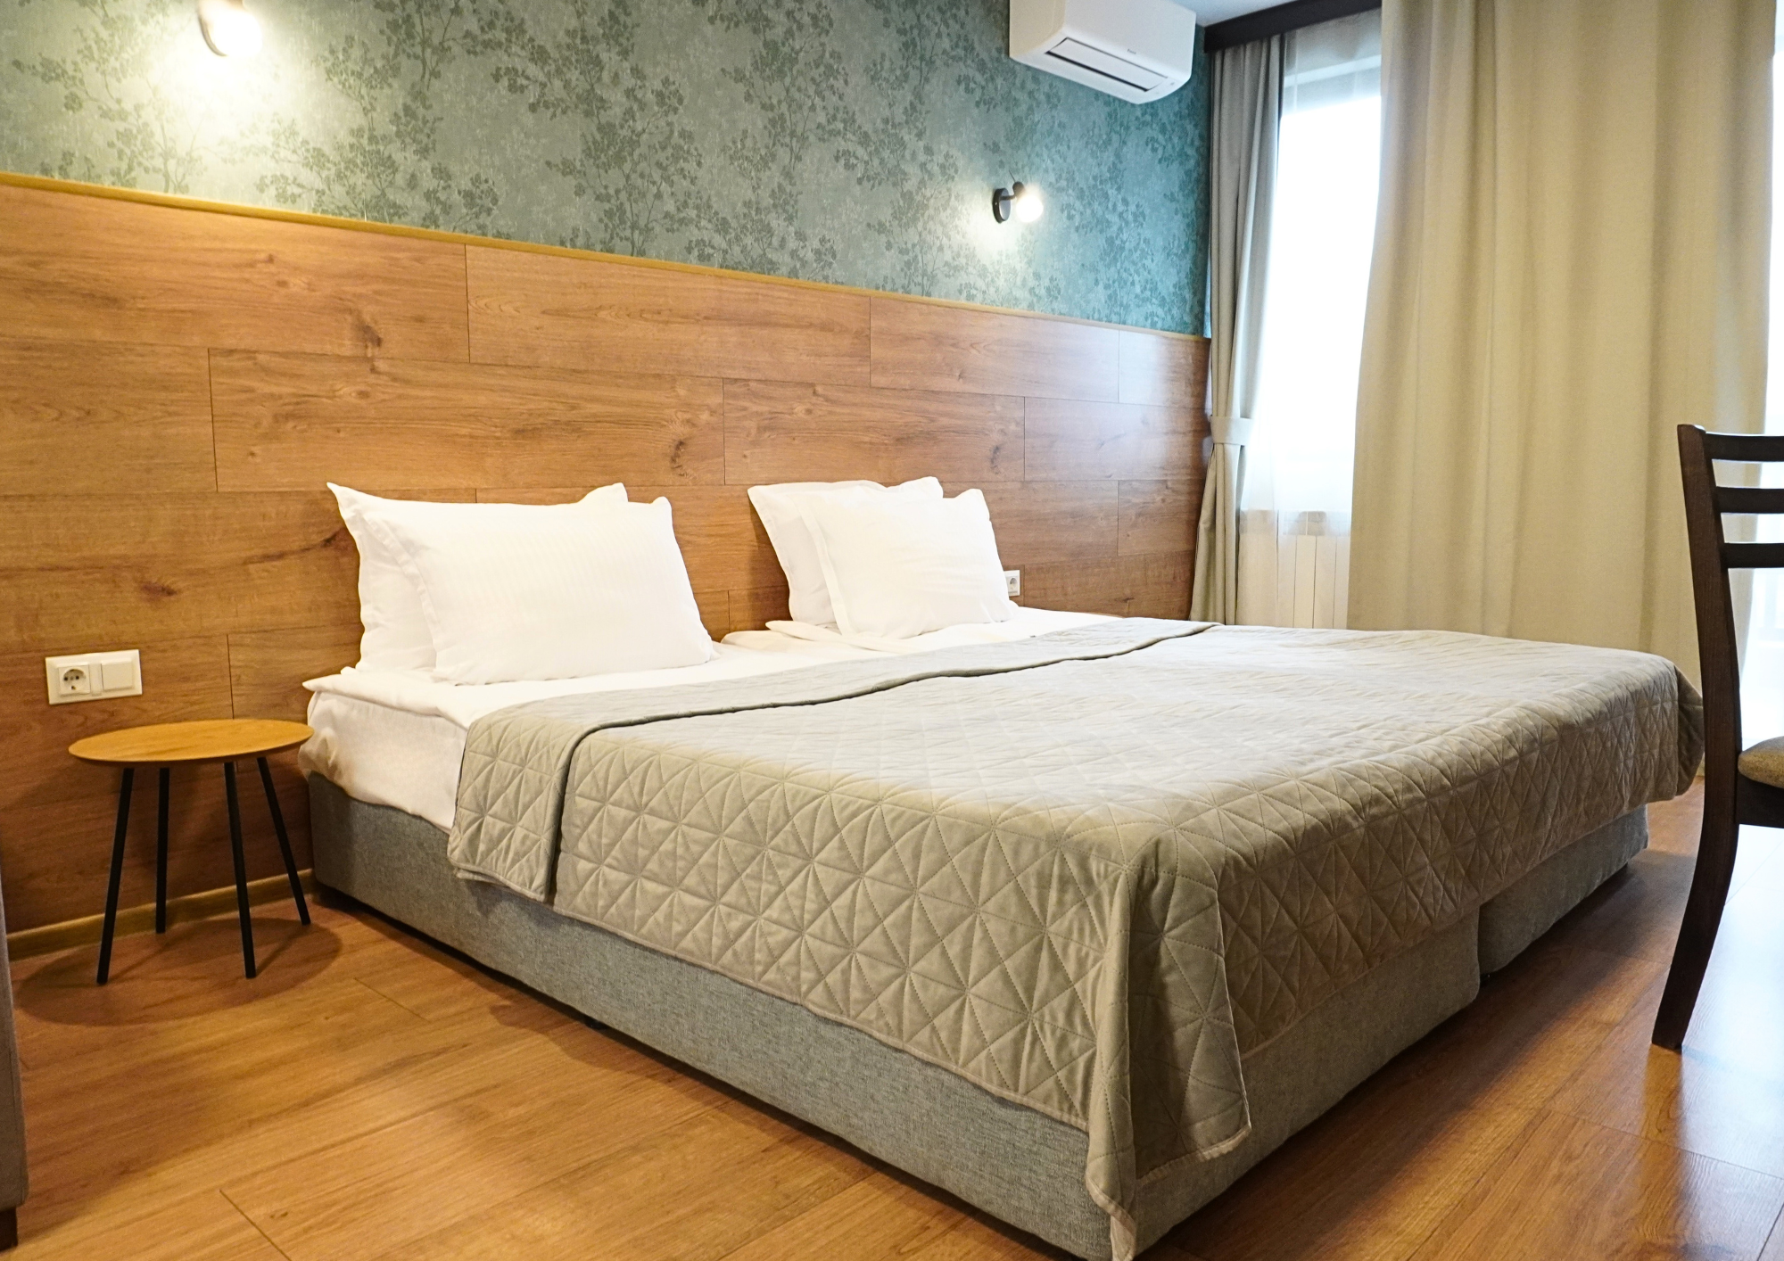  Double Room | 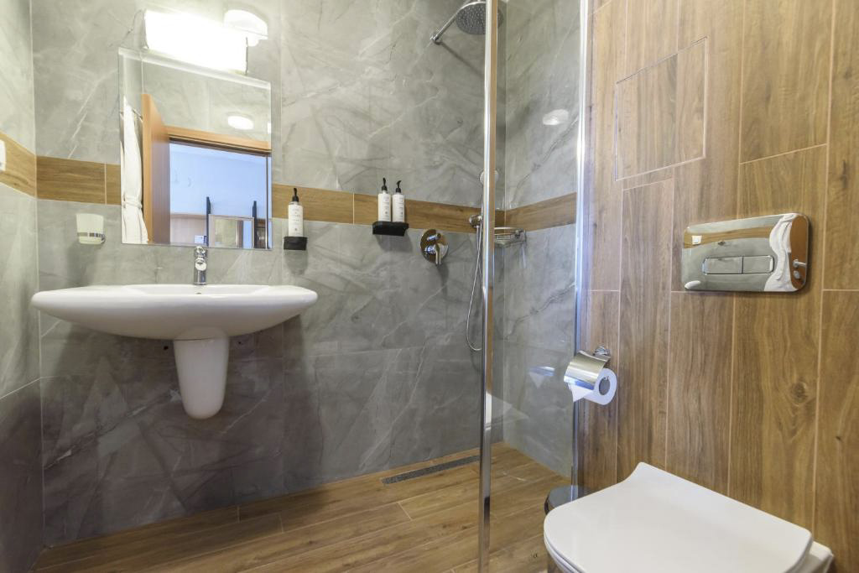  Bathroom
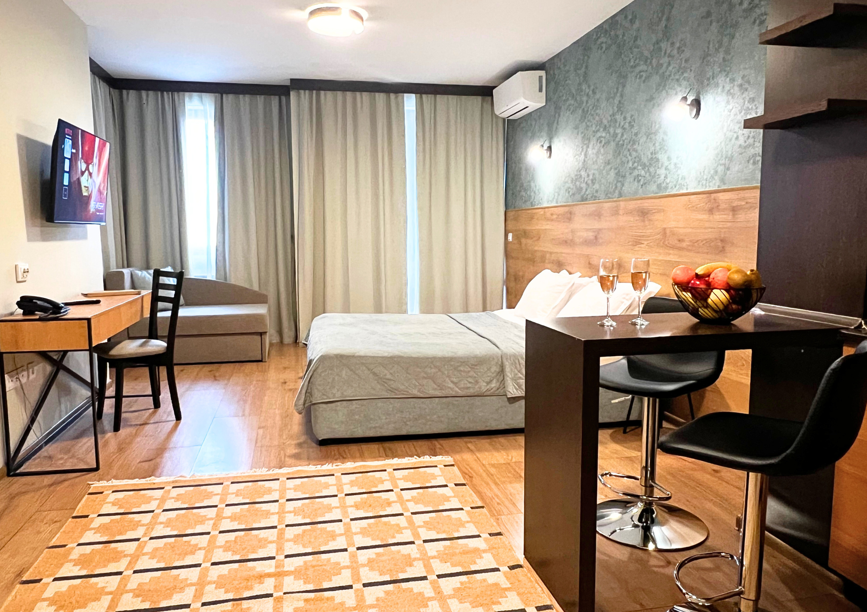  Studio | 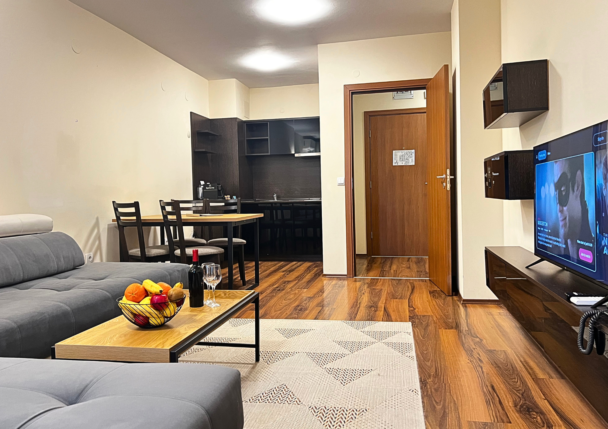  Apartment Living Room
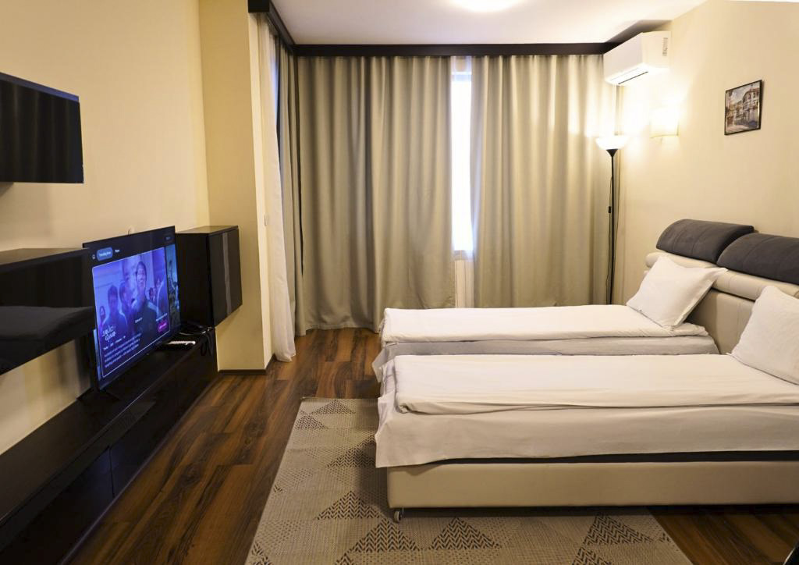
Additional Beds in the Living Room

Accommodation Details
- Double Room (30 m²): maximum occupancy 2 adults, 1 child and 1 baby. A double bed or two single beds, a 90 × 190 cm sofa bed, and a bathroom with a shower and toilet.
- Studio (35 m²): maximum occupancy 2 adults, 1 child and 1 baby. A double bed or two single beds, a 90 × 190 cm sofa bed, and a bathroom with a shower and toilet.
- One-Bedroom Apartment (55 m²): maximum occupancy 4 guests and 1 baby. A bedroom with a double bed and a separate living room with a sofa that converts into two separate 90 × 190 cm beds. A door separates the rooms. Bathroom with a bathtub or shower and toilet.
- Two-Bedroom Apartment (90 m²): maximum occupancy 6 guests and 1 baby. Two bedrooms — one with a double bed and one with two single beds — and a separate living room with a sofa that converts into two separate 90 × 190 cm beds. Doors separate the rooms. Bathroom with a shower and toilet, plus an additional toilet.
- Three-Bedroom Apartment (120 m²): maximum occupancy 8 guests and 1 baby. Three bedrooms — two with double beds and one with two single beds — and a separate living room with a sofa that converts into two separate 90 × 190 cm beds. Doors separate the rooms. One bathroom with a bathtub and toilet, a second bathroom with a shower and toilet, and an additional toilet.
- Hairdryer, electric kettle, minibar and coffee machine with complimentary coffee and tea.
- A full set of bathrobes, towels and slippers.
- JOIE de VIVRE toiletries made with 97% natural ingredients.

Spa and Wellness
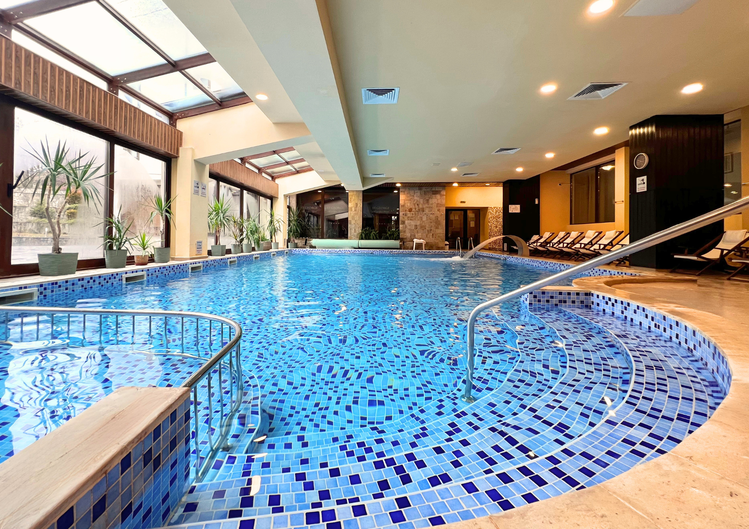 | 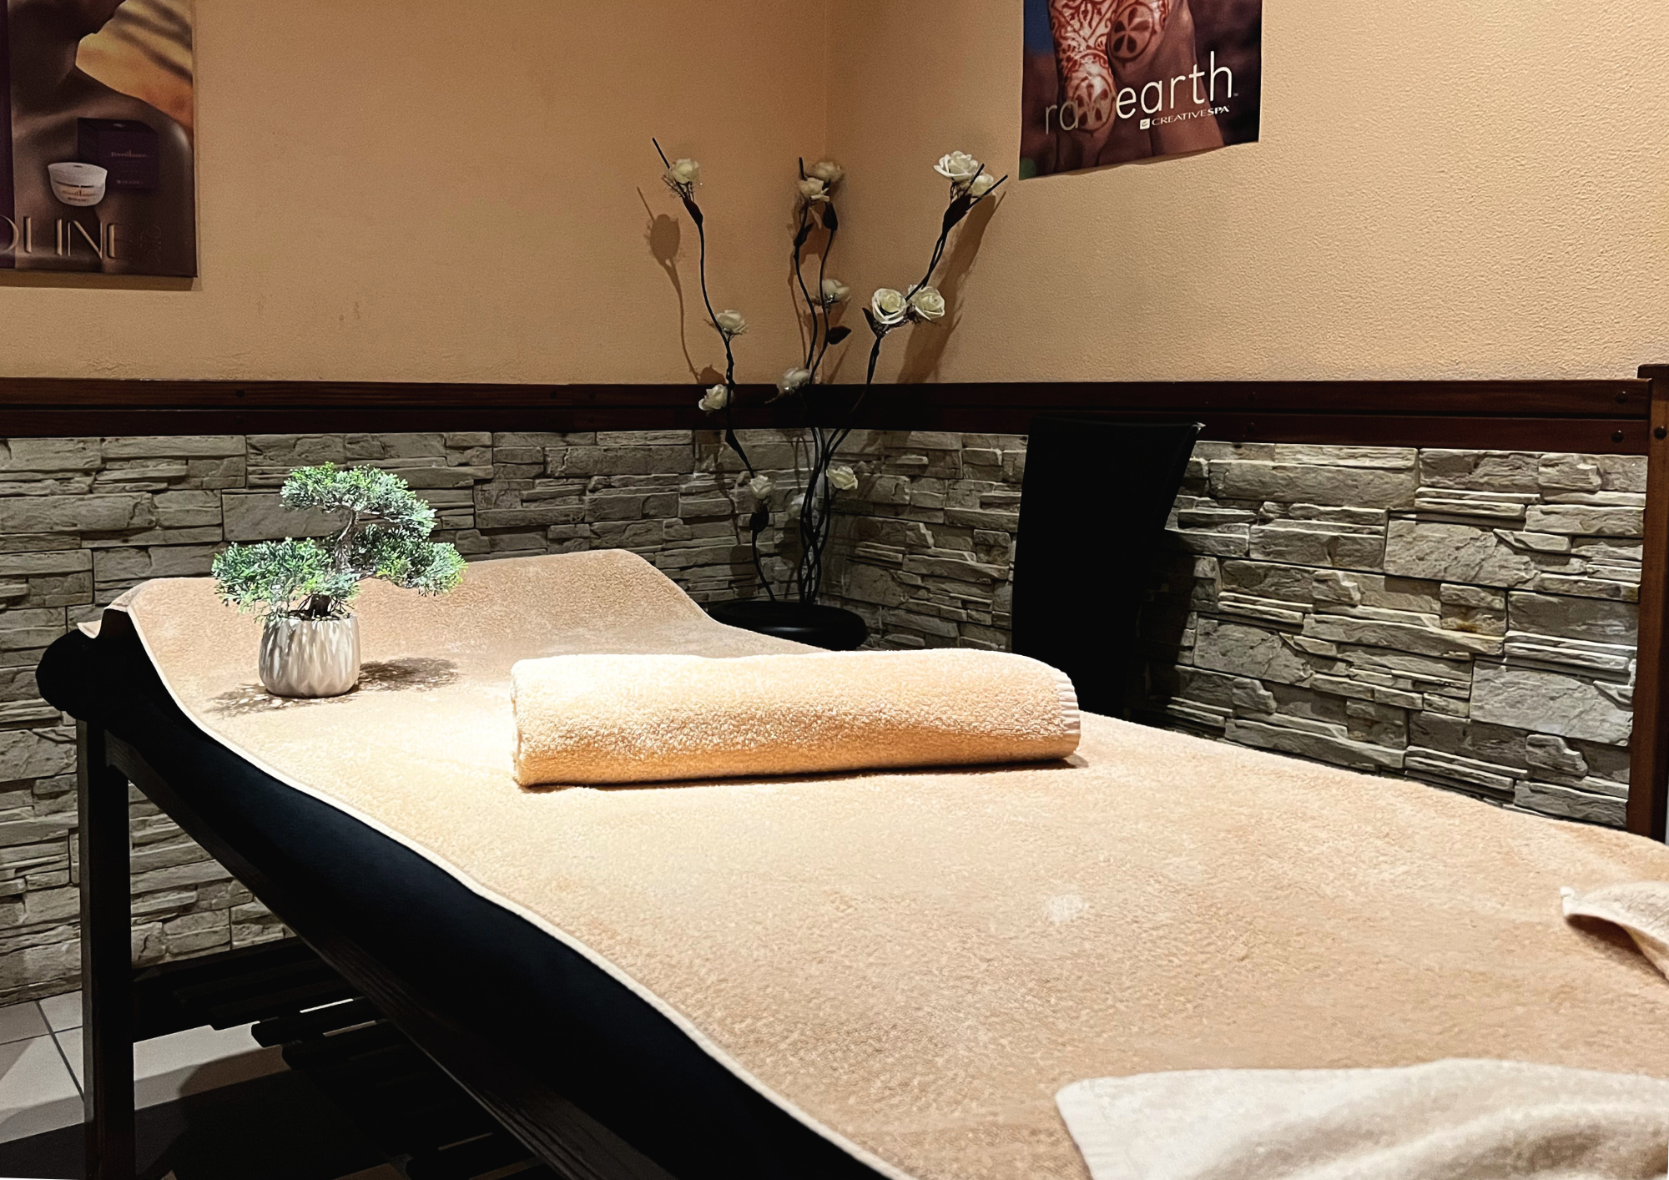
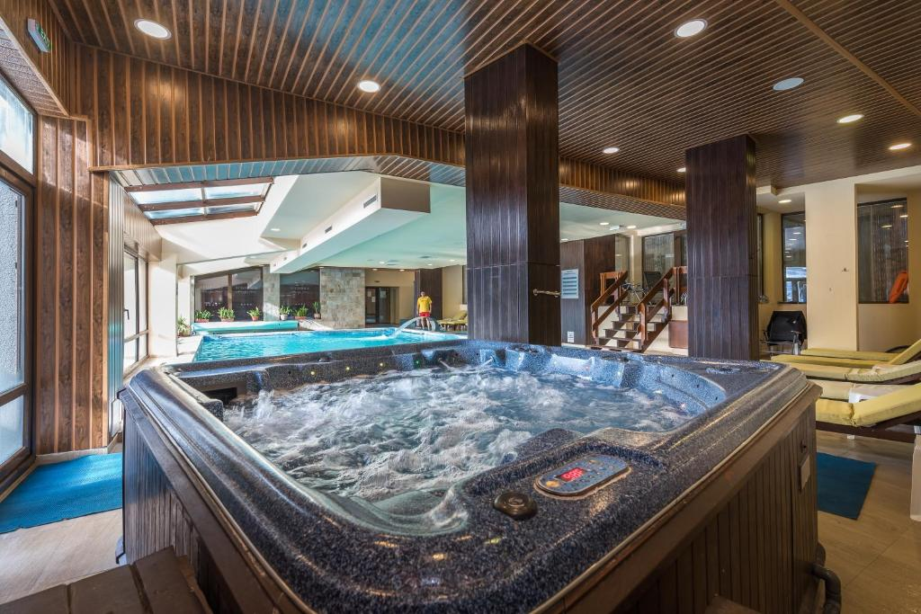
The spa and wellness centre offers the following facilities for relaxation and recovery:
- Indoor heated swimming pool with a water temperature of 32–33°C
- Indoor hot tub with a water temperature of 36°C
- Finnish sauna
- Aroma sauna
- Himalayan salt sauna
- Steam room
- Relaxation area with heated loungers
- Mineral drinking water in the spa area
- Salt room
- Turkish bath
- Fitness centre with 24-hour access

Restaurant and Dining
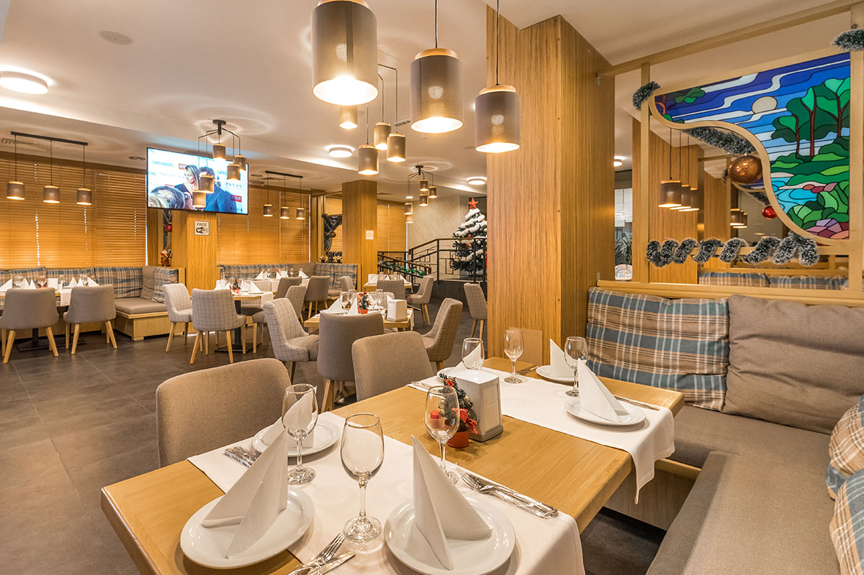
Dolce Vita Restaurant serves delicious home-cooked food prepared from scratch, using carefully selected fresh ingredients from local farms and producers in the region.
Breakfast in winter: 07:00–10:00; in summer: 07:30–10:00.
The menu combines classic dishes, local specialities and the head chef’s signature creations.
Themed dinners follow a seven-day menu cycle. The carving station features evening specialities such as whole fish, leg of lamb, turkey, paella and roast beef.

Family Holidays in Bansko
Spacious apartments and facilities for children make the hotel ideal for family holidays in every season.
- Children’s arcade games room
- Children’s play area, open 10:00–22:00
- Children’s section in the swimming pool
- Children’s entertainment six days a week
- High chairs in the restaurant and children’s bathrobes
- Complimentary baby cot on advance request
More time together. More family memories.

Useful Information for Your Stay
Check-in: from 15:00. Early check-in is possible if your room is ready.
Check-out: by 12:00.
Late check-out until 18:00 is subject to availability and costs 50% of the nightly rate for the relevant accommodation.
Cooking in the apartments is not permitted.
ST. GEORGE SKI & HOLIDAY 4*
Your place in Bansko, where the mountains inspire, active days refresh,
and comfort makes you feel at home.
www.stgeorgespabansko.com | reservations@stgeorgespabansko.com | +359 885 805 914

